Responsive Web Design with Media Queries

Theory Assignment
Question 1: What are media queries in CSS, and why are they important for responsive design?
Ans: Media queries in CSS are a way to apply different styles to a website based on the device or screen size it’s being viewed on. Think of them as a set of conditions that tell the browser, “If the screen is this wide, use these styles instead.
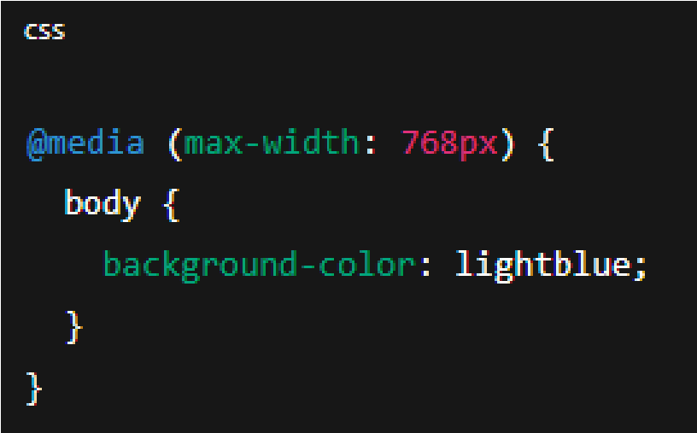

In this case, if the screen is 768 pixels wide or smaller (like on a tablet or mobile phone), the background colour of the website will change to light blue.
Why Are Media Queries Important for Responsive Design?
Responsive design means that your website adjusts smoothly to different screen sizes—whether someone is using a phone, tablet, laptop, or desktop. Media queries are essential for this because:
- They improve user experience: Visitors can easily read and navigate your site no matter what device they're using.
- They reduce the need for multiple versions of a site: Instead of creating a separate mobile site, media queries let you adapt one site to all devices.
- They make your site future-proof: As new devices with different screen sizes come out, your site can adapt with minimal changes.
- They help with SEO: Search engines like Google prioritize mobile-friendly, responsive websites.
Question 2: Write a basic media query that adjusts the font size of a webpage for screens smaller than 600px.
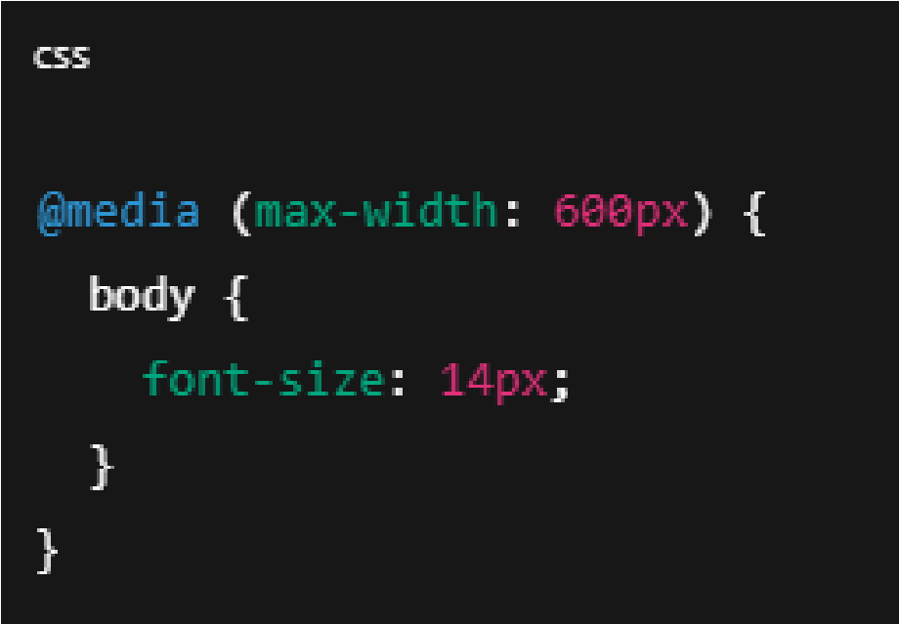
How it works?
- @media (max-width: 600px): This checks if the screen width is 600px or less.
- Inside the curly braces {}, we apply the styles we want to use for those small screens.
- font-size: 14px;: This sets the font size of the entire page (body text) to 14 pixels when the screen is small.

